**Spatio-temporal analysis of precipitation and its extreme values ​​for the Conchos River basin using the Standardized Precipitation Index**

**RESUMEN**

En el presente estudio se lleva a cabo un análisis espacio-temporal de la precipitación para la cuenca del Río Conchos. Se emplea el Índice Normalizado de Precipitación (mejor conocido como SPI en inglés), para conocer si existe algún tipo de manifestación potencial de cambio en el clima, en la cuenca, en las últimas décadas.

Se analizan y comparan dos periodos, el primero (antiguo) comprendido entre 1961 al 1984 y el segundo (reciente) entre 1985 al 2008. Para ello, se calcula un porcentaje de cambio del SPI en el cual se compara las frecuencias de ocurrencia de cierta categoría de SPI, para ambos periodos. La base de datos utilizada proviene de los datos climatológicos administrada por el Servicio Meteorológico Nacional de México (SMN) en modo malla. Los resultados apuntan claramente a que ha habido un incremento significativo de la amplitud y frecuencia de los eventos climatológicos extremos en la región. Lo anterior, en acuerdo a las proyecciones climáticas del último Reporte de Evaluación del Panel Intergubernamental sobre Cambio Climático (IPCC-AR-5). Donde se advierte que uno de los efectos potenciales más significativos de cambio climático tiene que ver con cambios en la variabilidad climática, o más explícitamente, con el incremento de los extremos climáticos tanto en duración como en intensidad. Además, se observa que muy probablemente la orografía puede ser un factor determinante en las diferencias del cambio en el comportamiento espacio-temporal del SPI. Finalmente, resalta la gran sequía en la región durante el periodo 1995-2003.

**ABSTRACT**

In the present study, a spatio-temporal analysis of the precipitation for the Conchos River basin is carried out. The Standardized Precipitation Index (SPI) is used to determine any potential manifestation of climate change in the basin, for the recent decades.

Two periods were analyzed and compared, the first (old) between 1961 and 1984 and the second (recent) period between 1985 and 2008. For that, a percentage of change of the SPI was calculated. In which, the frequencies of occurrence, of certain category of SPI, were compared for both periods. The database used comes from the climatological data maintained by the National Meteorological Service from Mexico (SMN), in mesh mode. The results clearly indicate that there has been a significant increase in the amplitude and frequency of extreme weather events in the region. The above, in agreement with the climate projections of the last Assessment Report of the Intergovernmental Panel on Climate Change (IPCC-AR5). Where it is noticed that one of the most significant potential effects of climate change has to do with changes in climate variability, or more explicitly, with increasing climatic extremes in both duration and intensity. In addition, it is observed that the orography may very well be a determining factor in the differences in the spatio-temporal behavior of SPI. Finally, it highlights the great drought in the region during the period 1995-2003.

1. **Introduction**

The Conchos River basin, is the most important socio-economic region for the state of Chihuahua, with an area of 71,964 km2, covers approximately 30% of the state's area and 14% of the Grande River basin (Kelly, 2001). The Conchos River as such has a length of approximately 900 km and is the main tributary, on the Mexican side, to the Bravo River. The basin has been under water stress in recent years due to increased demand from the agricultural, domestic and industrial sectors, and this situation has been aggravated by the occurrence of drought events (Nuñez-López et al., 2014). In addition, there is concurrent international pressure to comply with the International Treaty of 1944 in which it is established that Mexico must deliver annually to the United States 432 Mm3 of water to the Grande/Bravo River channel (Kelly, 2001). If this quota is not met, the debt accumulates every five years, with waters from the basin (Velasco et al., 2004).

In relation to the impacts and problems of water on the border, the Bravo River (Grande River in the US) has been known to be the largest source of water for the border of Mexico and the United States. The two sources of supply of this river are the mountains of San Juan south of the Rocky Mountains on the north side and the Sierra Madre Occidental in Mexico, which is the one that distributes to the Conchos River and the greater tributary of the Bravo River. A recent study performed a correlation of historical data of precipitation and runoff between both tributaries and showed no relationship at all (Woodhouse et al., 2012). However, despite this, several concurrent multiyear drought periods occurred over the past four centuries, most notably in the 1770s, 1890s, and 1950s. Another study presents a discussion on drought and its impacts on the socioeconomic and environmental sectors of Mexico (Ortega-Gaucin and Velasco, 2013). They also analyze the current vulnerability of the drought in Mexico and conclude that the main droughts in the country have affected mainly the agricultural sector and the rural population, and they have had a highly social character.

As for the impact of drought on the bilateral Mexico-US relationship, one of the major issues is the distribution of water in the Bravo River basin, because the law on the Mexican side is unclear (Soto and Escobedo, 2010). The authors point out that the distribution of water has not been constant over time, but rather responds to external factors such as changes in laws, drought and the creation of infrastructure that surely altered flows. However, they conclude that despite institutional efforts try to deal with this conflict, to date there are no elements to suggest that water treaties have not been followed.

From the climatic point of view, the northern region is characterized as the most arid in the country. As a result, the different drought periods that have occurred in the past have significantly aggravated the availability of water in the region. Several studies have already directly analyzed drought in the region (Kim et al., 2002; Kim et al., 2006; Núñez-López et al., 2007; Ortega-Gaucin, 2013), as well as their impacts (Soto and Escobedo, 2010; Woodhouse et al., 2012; Ortega-Gaucin and Velasco, 2013).

Several indices have been used to assess drought, however, in order to homogenize this concept, experts in the field developed and adopted the Lincoln Declaration (Hayes et al., 2011), which recommends that all National Meteorological and Hydrological Services (NMHSs) use SPI in addition to other indexes that they already used. In addition, a user guide was developed on this index and how to use it (OMM, 2012). The full version of the Lincoln Declaration on Drought Indices can be found at:

<http://www.wmo.int/pages/prog/wcp/agm/meetings/wies09/documents/Lincoln_Declaration_Drought_Indices.pdf>

Using the Palmer Drought Severity Index (PDSI), Kim et al. (2002) performed a spatial and temporal characterization of drought in the Conchos River basin. Their analysis showed a very severe drought during the 1990s and calculated a return period of 80 to 100 years over the basin. In the continuation of this work, Kim et al. (2006) proposed a method to estimate the bivariate return period of droughts which is dependent on the drought interarrival time and the joint distribution of drought properties. Other studies have analyzed drought in the region using relatively simpler methods (Nuñez-López et al., 2007), as the normalized precipitation index (SPI), which only uses precipitation as a parameter for the calculation of the index. Nuñez-López et al., evaluated the drought with SPI at different time scales: three, six and twelve months (SPI-3, SPI-6 and SPI-12 respectively). Drought conditions were found between 23 and 31% in the region at these time scales. Again, it was corroborated that the most important event of drought occurred in the mid and late of the 1990s. Another study focused on characterizing the hydrological droughts in the Bravo River basin to which Conchos belongs (Ortega-Gaucin, 2013). This study also corroborates that in most of the basin an extraordinary drought occurred between 1992-2005.

Using regression models, Nuñez-López et al. (2014) interpolated the average monthly precipitation in the Conchos River basin. In the study, 60% of 110 climatological stations in the study area were randomly chosen to reliably represent the spatial distribution of the variable in question and multiple step linear regression models were fitted to predict the variable as a function of elevation, the proximity to sea areas and the geographical location of the stations. The study finds a potential decrease in runoff in an area where there are already problems of overexploitation of aquifers. This conclusion is supported by another study in the region related to future scenarios which founds it would be challenging to compensate the lack of surface runoff since groundwater resources are already depleted (Rivas-Acosta and Montero-Martínez, 2013).

The present article shows a spatio-temporal analysis of SPI for the entire Conchos River basin in the period 1961-2008. For this, a percentage of change between two periods is calculated: 1961-1984 and 1985-2008. The idea is to contrast the possible spatial changes of the SPI in both periods, which could have some type of relation with climate change in that region.

1. **Data**

PRONACOSE information (National Program for Drought in Mexico) from CONAGUA (National Water Commission) was used to draw the boundaries of the basin [1](https://translate.googleusercontent.com/translate_f#footnote1) . Fig. 1 shows the limits of the Conchos basin as well as the zone level curves. Areas where the contour lines are more compact indicate the highest mountainous area.

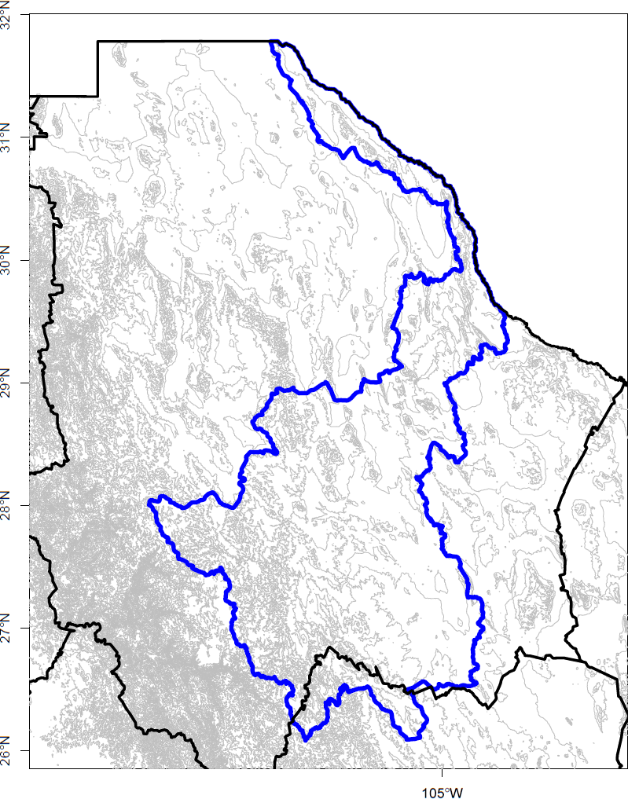

Fig. 1. Limits and orography of the Conchos River basin. The thick blue line shows the limits of the Conchos basin. The black line the limit of federative entities. Thin gray lines are level lines for the region indicating the higher parts when they are closer together.

For the analysis of the climatic variables, precipitation and surface temperature, we used the climatological mesh database created by CICESE[1] (which we will call CLICOMg here) which was generated from the official climatological database of SMN, which completely comprises more than 5000 stations and is stored in the system CLICOM (CLImatological COMputing). To create CLICOMg some tests on data quality were applied and data were interpolated to a regular grid using the Synographic Mapping System (SYMAP) (Shepard, 1984) method. The final product is a daily mesh database for precipitation and surface temperature (maximum and minimum) with spatial resolution of 1/8° for all Mexico (Zhu and Lettenmier, 2007; Muñoz-Arriola et al., 2009). The graphical platform was developed by the CICESE and can be viewed in the link: [http://clicom-mex.cicese.mx/malla](https://translate.google.com/translate?hl=es&prev=_t&sl=es&tl=en&u=http://clicom-mex.cicese.mx/malla) .

The available CLICOMg database covers a total period from 1960-2008 and from which the entire information period was occupied.

1. **Standardized Precipitation Index**

One of the most effective and simple methods to characterize drought is undoubtedly the normalized precipitation index (McKee et al., 1993; McKee et al., 1995). SPI is a simple and flexible method because only precipitation is needed to calculate it, and it can analyze both wet and dry periods. This is based on the probability of precipitation for any time scale. Taking into account the observed precipitation, the probability of precipitation becomes an index, which is currently used in research or in operational mode in more than 70 countries (OMM, 2012).

The calculation of SPI for any locality is based on the recording of long-term precipitation for a desired period. This long-term record is adjusted to a probability distribution and then transformed into a normal distribution so that the average SPI for the locality and the desired period is zero (Edwards and McKee, 1997). The positive values ​​of SPI indicate that precipitation is greater than the median, and negative values, which is lower (OMM, 2012). The values ​​of the index are categorized as recommended by WMO and are presented in Table I.

Table I. Values ​​and probabilities of occurrence of the normalized precipitation index.

|  |  |  |
| --- | --- | --- |
| SPI | Category | Probability |
| ≥ 2.0 | extremely wet (ew) | 0.023 |
| 1.5 to 1.99 | severely wet (sw) | 0.044 |
| 1.0 to 1.49 | moderately wet (mw) | 0.092 |
| -0.99 to 0.99 | approximately normal (an) | 0.682 |
| -1.0 to -1.49 | moderately dry (md) | 0.092 |
| -1.5 to -1.99 | severely dry (sd) | 0.044 |
| ≤ -2 | extremely dry (ed) | 0.023 |

The SPI-12 was calculated for the period 1961-2008, for the calculation of the SPI of January of 1961 the 12 months of 1960 are used, for February of 1961 the last 11 months of 1960 are used and the first month (January) of 1961, and so on.

The methodology described by Edwards and McKee (1997), originally implemented in the programming languages ​​C and FORTRAN and later in the computational language R by Wheatley (2010), was used to calculate the SPI. This methodology is shown graphically in Fig. 2.

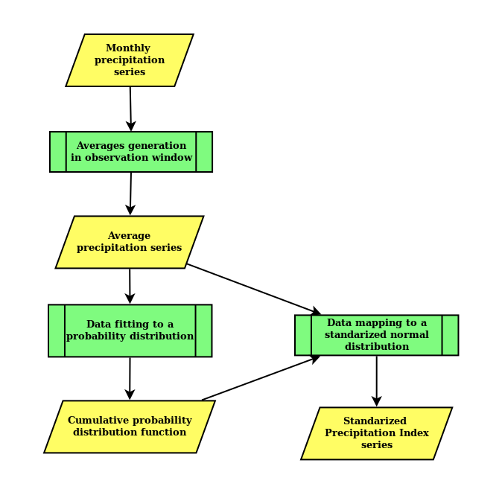

Fig. 2. Steps for generating SPI series. The rectangles represent processes or sets of actions, whereas the rhomboids represent inputs or outputs to these processes.

The starting point of the procedure is a monthly series of precipitations over a long period of time, recommended for at least 30 years. For generating a series of averages, it is taken a *window* of *n* months back the month in question and a simple average is calculated. While the number of months covering the window, *n*, is arbitrary, it is common to take it between 3 and 48 months to observe climatic phenomena at different time scales (McKee, et al., 1993). The result is a series of averaged precipitations, which is used to adjust to some kind of cumulative probability distribution function. It has been suggested to adjust the data to the Gamma probability distribution (McKee, et al., 1993). Although the issue of what type of probability distribution best represents rainfall is still a matter of open discussion (Hanson & Vogel, 2012), the selection of the two-parameter Gamma continuous distribution manifests some representative advantages, specifically for the calculation of SPI, which have been noted elsewhere (Guttman, 1999). Another approach to fit a cumulative distribution function of probabilities, is the use of a non-parametric statistical function known as the empirical cumulative distribution function (*ecdf*), which can be determined directly from the data (Vaart, 1998, p.265). In either case, the adjustment is not made on the total data of the series of averages, but on a stratification of them per month, so that there would be twelve adjusted functions whose application to a particular precipitation would depend on the month in which it is located (Guttman, 1999). The final step in the methodology is to map the data, that is, the series of monthly precipitation averages to a series of SPI indices. This step takes as input the series of precipitation averages on the one hand and, on the other, the cumulative probability distribution function. Thus, as shown in Fig. 3, for each of the precipitation averages of the series a probability is obtained, and this probability is used as input for the inverse, or quantile, of the normal cumulative probability standardized function to obtain the SPI that corresponds to that average precipitation. By applying this procedure to each average of the series, a time series of SPIs is obtained.

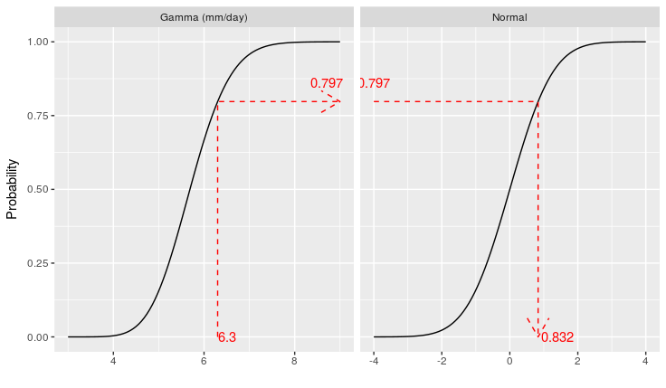

Fig. 3. Mapping of an average precipitation to its SPI.

If, instead of the cumulative Gamma probability distribution function, the empirical cumulative distribution function had been used, the appearance of the left-hand plot in Fig. 3 would have been that of a ladder-type function. The advantage of using the cumulative function *ecdf*, on any parametric probability distribution function is that it operates directly on the data and not on an approximation of them. For this reason, in this work, the precipitation was fitted to an *ecdf* function which was used to calculate the time series of SPIs, following the implementation of Wheatley (2010).

The present study focuses only on the results of SPI-6 and SPI-12, that is, those that have been calculated with a window of observation of 6 and 12 months respectively, with a special emphasis on wet or dry periods of median and long duration respectively. These periods generally have a greater impact in the environmental and social sectors of any region.

We then analyze the behavior of the SPI, at 6 and 12 months, for the 24-year periods of 1961-1984 (called here old period) and 1985-2008 (recent period). The idea is to make a comparison of the potential change in the SPI of one period with respect to another. For this, the percentage of change *r* was calculated, which was defined as:

Where *h1* is the value of the number of times a given SPI level is inside the 288 available months of the recent period 1985-2008; *h0* is the equivalent value, but for the old period 1961-1984. Thus, this rate of change provides a quantitative idea of ​​the observed change in the frequency of very rainy or very dry periods of one period with respect to another and so it is possible to determine if there has been a significant change in the climate of the region from the point of view of monthly precipitation.

1. **Results**

The spatial structure of the annual mean precipitation of the Conchos River basin during the entire study period 1961-2008 shows higher precipitation in the southwestern part of the basin (Fig. 4). The rainy zone, with values ​​between 600 and 800 mm annually, corresponds to the mountainous region (Fig. 1). A gradient is identified in the average precipitation that decreases towards the southeast. In the lower central part of the basin, values ​​around 400 mm per year are observed, as well as in the area between 29 and 31°N. The most arid extent of the basin is the northernmost region with values ​​around 300 mm.

The average annual precipitation cycle, integrated for the basin (Fig. 5), shows a type of monsoon precipitation. Where there is a significant difference between the driest months (November to May) and the wettest (June to October). Precipitation, in the dry months, does not exceed 0.5 mm/day whereas in the wet precipitation is around 1 to 3 mm/day. The rainy months (July, August and September) are consistent with the Mexican or North American monsoon season reported in previous studies (Higgins and Gochis, 2007, Gochis et al., 2007).

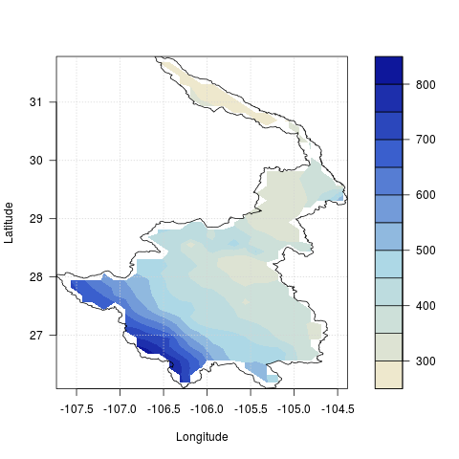

Fig. 4. Average annual precipitation (mm) in the Conchos River basin.

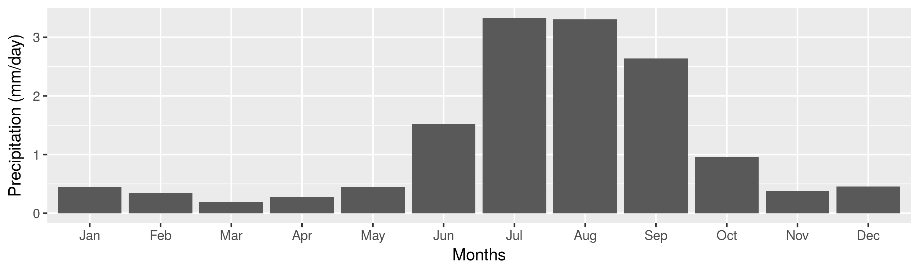

Fig. 5. Average annual precipitation cycle (mm/day) in the Conchos River basin.

The monthly precipitation anomaly (Fig. 6a) shows greater, in magnitude and frequency, extreme anomalies (around the magnitude of maximum precipitation), both positive and negative, in the old period (1961-1984) than in the recent (1985-2008). This indicates a possible change in the precipitation pattern for both periods. These changes are clearly observed in the time series, for the period 1961-2008, of SPI-6 and SPI-12 (Fig. 6b and c), especially SPI-12. These characteristics in the precipitation pattern are more evident in the SPI time series (Figure 6b and c). In both SPI, indices indicating extreme values (SPI > |1|) of precipitation (wet and dry) are identified. In general, as expected, there is a greater variability in SPI-6 compared to SPI-12, which is a direct result of the SPI definition, as the field of variation of the SPI-12 is smoothed. To demonstrate the above, the Pearson correlation coefficient was calculated between the time series of the SPI-6 and the SPI-12 given a value of 0.741.

For the old period in SPI-6 (Figure 6b), an extremely wet event (SPI  2) is identified before 1970 and almost 10 years after another. During this interval, two moderately wet, two moderately dry, one severely dry and two extremely dry events are observed. For the recent period in SPI-6 (Figure 6b), there is a similar behavior as in the old one. Between 1992 and 2005 the two extremely wet events were observed, separated by about ten years. But unlike the old period, during this interval only events occur from extremely dry to moderately dry. That is, longer drought events.

The difference in precipitation pattern between the two periods is most evident in SPI-12 (Figure 6c). Where for the recent period it is observed that the event of drought is more prolonged (approximately ten years). On the other hand, also the events of extreme rains are more prolonged and intense. This last drought event, described from the recent period, is congruent with what was found in previous studies (Ortega-Gaucin, 2013). Given the time period, this could mark a significant change in the form of precipitation in the region and therefore in the climate of the same. These changes, in the precipitation pattern, may be effects of climate change. Given that that this result is in agreement with climate projections stated by the IPCC at the regional level, where it is expected that under climate change conditions there will be an increase in intensity and amplitude of extreme values as shown by the previous result (IPCC, 2014).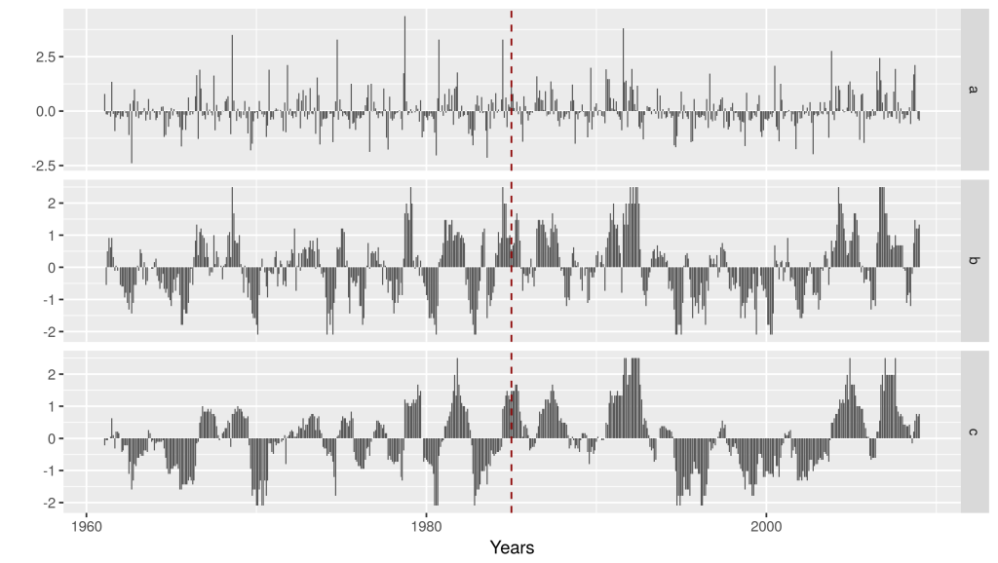

Fig. 6. (a) Precipitation anomaly (mm/day), (b) SPI-6 and (c) SPI-12 months for the Conchos River basin. The dotted line marks the division of the old and recent periods of this study (January 1985).

With the SPI calculations, we also performed an analysis of the spatial structure of extreme events for the basin. The percentage of SPI change compares the frequencies of SPI, for each category (Table 1), in the periods mentioned above (Figs. 7 and 8). The bluish tones indicate positive values in the percentage of change, ​​which means that the recent period (1985-2008) dominates in terms of the frequency (number of times) that a certain category of SPI occurred for the entire period. The red tones imply the opposite, that is, now the old period (1961-1984) dominates.

It is noteworthy that the entire western part of the basin, the most mountainous part, dominates the SPI of the old period in terms of the frequency of different types of drought, and in the central and southeast part, the SPI of the recent period generally dominates (Fig. 7). As for the moisture results the maps are not exactly complementary. For example, for the extreme humidity case it can be seen that the old period dominates again, as in extreme drought case, in the frequencies around 28°N and 107°W, the same occurs around 29.5°N and 105°W. Contrasts between both periods are usually higher while more extreme SPI values are, a result that is not surprising at all, given the low probability of occurrence of extremes (2.3%).

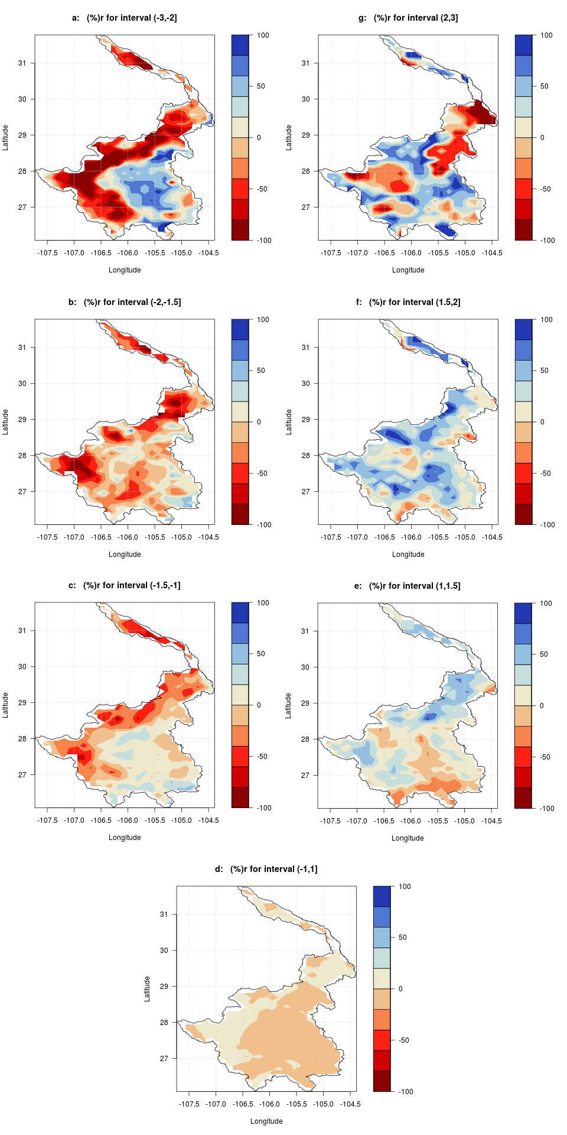

Fig. 7. Percentage change of SPI-6 for the Conchos River basin at different SPI levels: (a) extremely wet; (b) severely wet; (c) moderately wet; (d) approximately normal; (e) moderately dry; (f) severely dry; (g) extremely dry. The bluish tones indicate the regions where the frequencies of the recent period dominate (1985-2008), and the red tones indicate the dominion of the old period (1961-1984).

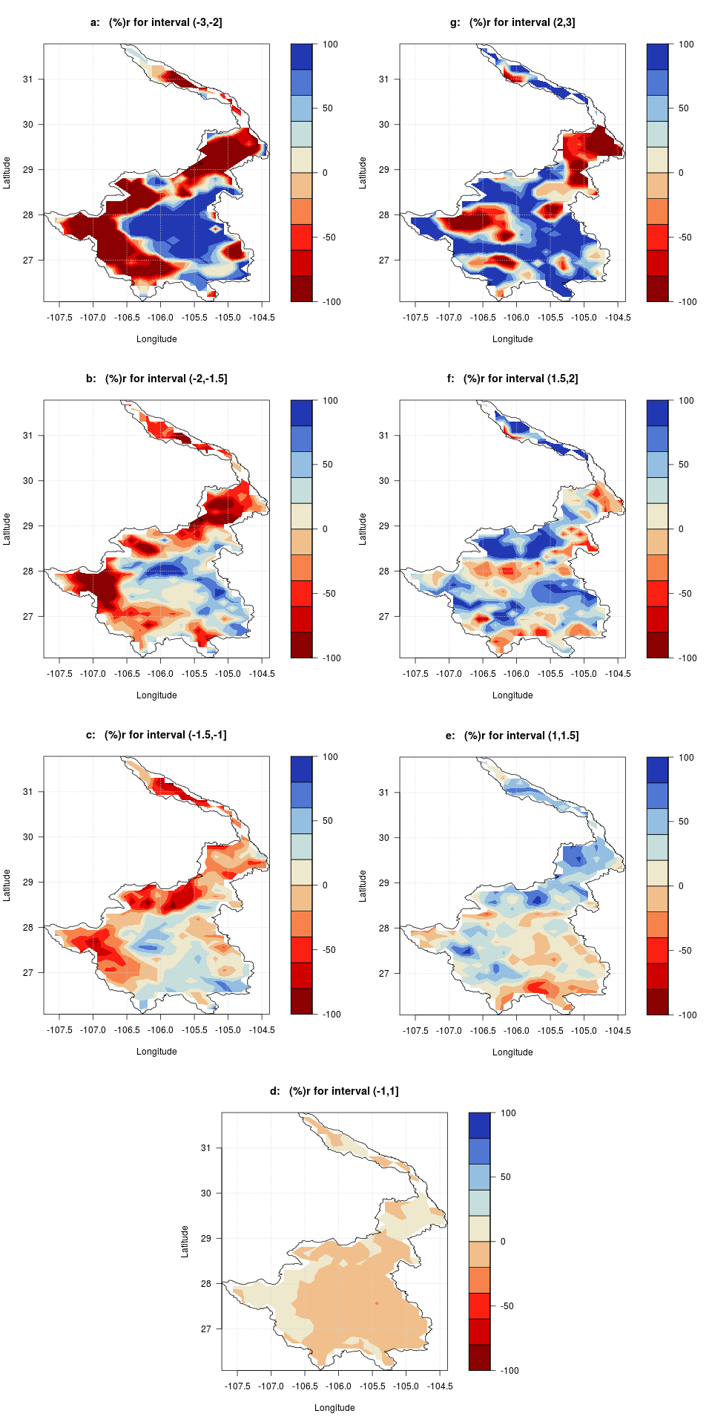

Fig. 8. Same as in Fig. 7 but for SPI-12.

For SPI-12 months (Fig. 8) it is observed that in general there is a greater contrast between the values ​​of the percentage of change compared to the result for SPI-6, especially for the more extreme values. In general, there is good spatial correspondence between both SPI-6 and SPI-12 results, although some regional differences in SPI values ​​are noted when it is closer to normal. Again, the dominance of the old period for droughts towards the most mountainous region of the basin is noted. In contrast, the recent period dominates towards the central part for droughts. For the wet case, a dominance of the recent period in much of the basin is noted. For SPI "normal" the differences between periods are not that significant, although there is a slight tendency of the old domain towards the central and southwest part of the basin and the recent period towards the mountainous part of the basin.

In order to analyze the spatial consistency between the results of SPI-6 and SPI-12, Pearson correlation coefficients are shown between the spatial results of Fig. 7 and Fig. 8 (Table II). The highest spatial correlation was found for the moderately wet case and the lowest for the severely drought case.

Table II. Pearson correlation between data presented in Figs. 7 and 8.

|  |  |
| --- | --- |
| Category | Pearson Corr. |
| extremely wet (ew) | 0.83 |
| severely wet (sw) | 0.65 |
| moderately wet (mw) | 0.76 |
| approximately normal (an) | 0.84 |
| moderately dry (md) | 0.86 |
| severely dry (sd) | 0.76 |
| extremely dry (ed) | 0.85 |

Finally, integrating the previous results for the entire basin shows the fraction of change between the two periods for the different levels of SPI (Fig. 9). It is observed how the wet periods have increased towards the last decades for SPI-6 and SPI-12. While for the dry periods there is no generalized conclusion since SPI-6 shows a decrease and SPI-12 increases in general towards the last decades.

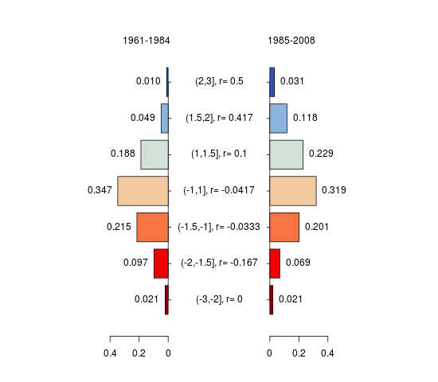 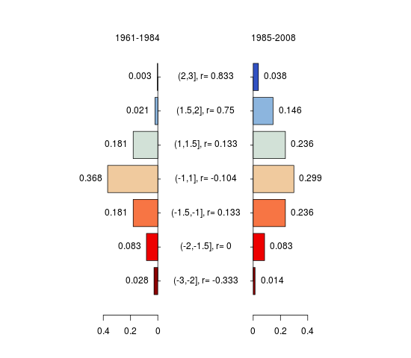

Fig. 9. SPI-6 (left) and SPI-12 (right) change fraction for the whole basin, comparing the old (1961-1984) and recent (1985-2008) periods.

1. **Conclusions**

The analysis of SPI shows that the mountainous area to the west of the region (Fig. 1) seems to play a decisive role on the fact that a large part of the extreme droughts occurred in that area but only during the old period (1961-1984) mainly. One of the possible causes of this result could be some type of land use change that is affecting the biota of the mountainous region and with it the way to precipitate there. Extreme droughts in the lower part of the basin (central and southeast) were present mostly in the most recent period.

On the other hand, it was proved that there is a good spatial and temporal correlation between SPI-6 and SPI-12 (Table II), which by the definition of SPI should not be that surprising.

According to the synthesis of results presented in Fig. 9 for the whole basin, it is observed how the wet periods have increased towards the last decades for both SPI. While for the dry periods there is no generalized conclusion since SPI-6 shows a decrease and SPI-12 increases in general towards the most recent period.

What is a strong fact is that the dry and wet periods are intensifying in magnitude and increasing in duration towards the last decades as could be corroborated in Fig. 6. This result is consistent with what is continually mentioned by the IPCC, 2007; IPCC, 2014) in their most recent evaluation reports as a consequence of climate change at the regional level.

This last result is particularly important and worrying to continue in the near future as it is now a region that is strategic and has serious water availability problems.

A final interesting result is the fact that the drought period between 1995 and 2003 was clearly shown, which had already been noticed by other previous works such as Ortega-Gaucin (2013).

Data and programs of this study are available through the website ( [www.github.com/juliosergio/DosCuencas](https://translate.google.com/translate?hl=es&prev=_t&sl=es&tl=en&u=http://www.github.com/juliosergio/DosCuencas) ).

**References**

Edwards D. C. and McKee T. B.,1997. Characteristics of 20th century drought in the United States at multiple time scales. Climatology report 97-2. Atmospheric science paper No. 634. Colorado State University, Department of Atmospheric Science. URI: <http://hdl.handle.net/10217/170176>. May, 1997.   
Implementation notes and code of this work can be found in URI: <http://ccc.atmos.colostate.edu/standardizedprecipitation.php>

Gochis D. J., Watts C. J., Garatuza-Payan J., and Cesar-Rodriguez J., 2007. Spatial and temporal patterns of precipitation intensity as observed by the NAME event rain gauge network from 2002 to 2004. Journal of Climate, 20(9), 1734-1750.

Guttman N. B., 1999. Accepting the Standardized Precipitation Index: a calculation algorithm. JAWRA Journal of The American Water Resources Association 35(2), 311-322. April, 1999.

Hanson L. S. and Vogel R., 2012. The Probability Distribution of Daily Rainfall in the United States. World Environmental and Water Resources Congress 2008. American Socity of Civil Engineers. Published online: April 26, 2012. DOI: 10.1061/40976(316)585.

Hayes M. J., Svoboda M. D., Wall N., and Widhalm M., 2011. The Lincoln declaration on drought indices: universal meteorological drought index recommended. Bulletin of the American Meteorological Society, 92(4), 485-488.

Higgins W. and Gochis D., 2007. Synthesis of results from the North American Monsoon Experiment (NAME) process study. Journal of Climate, 20(9), 1601-1607.

IPCC, 2007. Bernstein, L., Bosch, P., Canziani, O., Chen, Z., Christ, R., y Riahi, K. (2008). Climate change 2007: synthesis report. IPCC.

IPCC, 2014. Pachauri, R. K., Meyer, L., Plattner, G. K., y Stocker, T. (2015). Climate Change 2014: Synthesis Report. Contribution of Working Groups I, II and III to the Fifth Assessment Report of the Intergovernmental Panel on Climate Change. IPCC.

Kelly E. M., 2001. El Rio Conchos: un informe preliminar. Texas center for policy studies. available from world wide web: <http://www.texascenter.org/publications.html#texasmexico> (available April, 2017).

Kim T. W., Valdés J. B., and Aparicio J., 2002. Frequency and spatial characteristics of droughts in the Conchos River Basin, Mexico. Water International 27(3), 420-430.

Kim T. W., Valdés J. B., and Yoo C., 2006. Nonparametric approach for bivariate drought characterization using Palmer drought index. Journal of Hydrologic Engineering 11(2), 134-143.

McKee T. B., Doesken N. J., and Kleist J., 1993. The relationship of drought frequency and duration to time scales. In Proceedings of the 8th Conference on Applied Climatology (Vol. 17, No. 22, pp. 179-183). Boston, MA: American Meteorological Society.

McKee T. B., Doesken N. J., and Kleist J., 1995. Drought monitoring with multiple time scales. In Proceedings of the 9th Conference on Applied Climatology (pp. 233-236). Dallas, Boston, MA: American Meteorological Society.

Muñoz-Arriola F., Avissar R., Zhu C. and Lettenmaier D. P., 2009. Sensitivity of the water resources of Rio Yaqui Basin, Mexico, to agriculture extensification under multiscale climate conditions. Wat. Res. Res. 45 (11), DOI: 10.1029/2007WR006783.

Núñez-López D., Muñoz-Robles C. A., Reyes-Gómez V. M., Velasco-Velasco I., and Gadsden-Esparza H., 2007. Caracterización de la sequía a diversas escalas de tiempo en Chihuahua, México. Agrociencia 41(3), 253-262.

Núñez-López D., Treviño-Garza E. J., Reyes-Gómez V. M., Muñoz-Robles C. A., Aguirre-Calderón O. A., and Jiménez-Pérez J., 2014. Uso de modelos de regresión para interpolar espacialmente la precipitación media mensual en la cuenca del río Conchos. Revista Mexicana de Ciencias Agrícolas 5(2), 201-213.

OMM, 2012. Guía del usuario sobre el Índice normalizado de precipitación (OMM-Nº 1090) (M. Svoboda, M. Hayes y D. Wood), Ginebra.

Ortega-Gaucin D., 2013. Caracterización de las Sequías Hidrológicas en la Cuenca del Río Bravo, México. Terra Latinoamericana 31(3), 167-180.

Ortega-Gaucin D., and Velasco I., 2013. Aspectos socioeconómicos y ambientales de las sequías en México. Aqua-LAC 5(2), 78-90.

Rivas-Acosta I. and Montero-Martínez M. J., 2013. Downscaling technique to estimate hydrologic vulnerability to climate change: an application to the Conchos River Basin, Mexico. Journal of Water and Climate Change, 4(4), 440-457.

Shepard D. S., 1984. Computer mapping: The SYMAP interpolation algorithm. Spatial Statistics and Models, G. L. Gaile and C. J. Willmott, Eds., D. Reidel, 133-145.

Soto V. G. and Escobedo J. L., 2010. El desempeño de las instituciones en el manejo y control de las aguas superficiales del río Bravo: una perspectiva estadística. Revista de Ingeniería Hidráulica y Ambiental 31(2), 50-60.

Vaart A. W. van der, 1998. Asymptotic statistics. Cambridge University Press, ISBN 0-521-78450-6. The Edinburgh Building, Cambridge CB2 2RU, UK, 1998.

Wheatley J., 2010. Standardized Precipitation Index Code. Description and code avaliable in URI: <https://joewheatley.net/2010/03/>.

Woodhouse C. A., Stahle D. W., and Villanueva-Díaz J., 2012. Rio Grande and Rio Conchos water supply variability over the past 500 years. Clim. Res. 51, 147-158.

Velasco-Velasco I., Aparicio F. J., Valdés J., and Velázquez J., 2004. Evaluación de índices de sequía en las cuencas afluentes del Río Bravo-Grande. Ingeniería Hidráulica en México, 9(3):37-53.

Zhu C. and Lettenmaier, D. P., 2007. Long-Term Climate and Derived Surface Hydrology and Energy Flux Data for Mexico: 1925–2004. J. Climate 20, 1936-1946.

1. Centro de Investigación Científica y de Educación Superior de Ensenada.